Inclined Surface, Conservation of Mechanical Energy
Objectives: Study energy conservation on an inclined-surface.
Tools: An inclined surface (Ramp), a block to slide, a timer, photogates, and metersticks
Part 1. Physics Laws and Mathematics Presentations:

1. Key Concepts:
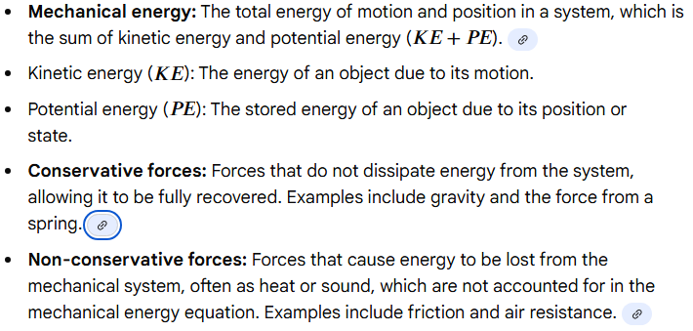

2. How can the mechanical energy be conserved?
If there are no non-conservative forces doing work, then mechanical energy is conserved.

3. What is the conservation of mechanical energy?

4. What is the mathematical presentation of conservation of mechanical energy?
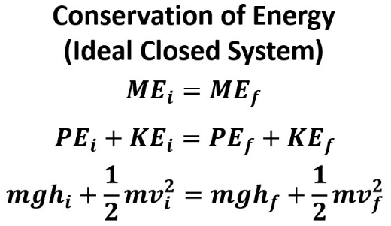
5. If there is work done by the non-conservative forces, then the mechanical energy is not conserved, but the total energy is still conserved. Conservation of Energy in a non-ideal system:
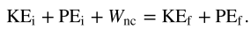

Part 2
1. Set up an inclined surface. 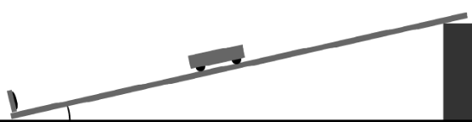

2. Mass the block m=________, convert the mass into kg: m=____________Kg.

3. Let the block slide down the inclined surface. Use a meterstick to measure the initial height to slide. Write and compute the initial potential energy of the block:
h=_____ , $PE_{i}=mgh=$_____________
4. Use a photogate to measure the final speed of the block at the end of the inclined surface. Write and compute the final kinetic energy: $v_{f}=$____________, ${KE_{f}=\frac{1}{2}mv_{f}^{}}^{2}$_________________

5. Let the block slide down 3 times with different heights, record heights and corresponding final velocities:
 | First | Second | Third
Initial Height h in meters
Final velocity $v_{f}$ in m/s
Time t to slide in seconds

Choose your most confident data h and $v_{f}$ to compute initial potential energy and final kinetic energy:

6. Compute the total initial mechanical Energy:
$ME_{i}$=$PE_{i}$+$KE_{i}$= ________________________
Compute the total final mechanical Energy:
$ME_{f}$=$PE_{f}$+$KE_{f}$= ________________________

7. Is the mechanical energy of the block conserved while it slides down the ramp? Explain why.

8. Compute the work done by the resistive forces (mostly the frictional force).

9. How much energy is transferred to thermal energy due to the work done by friction?

10. Measure the time it takes the block to slide down. Compute the power of the friction.
Power =$\frac{Work}{time}$

